Ануфриев Андрей 465029

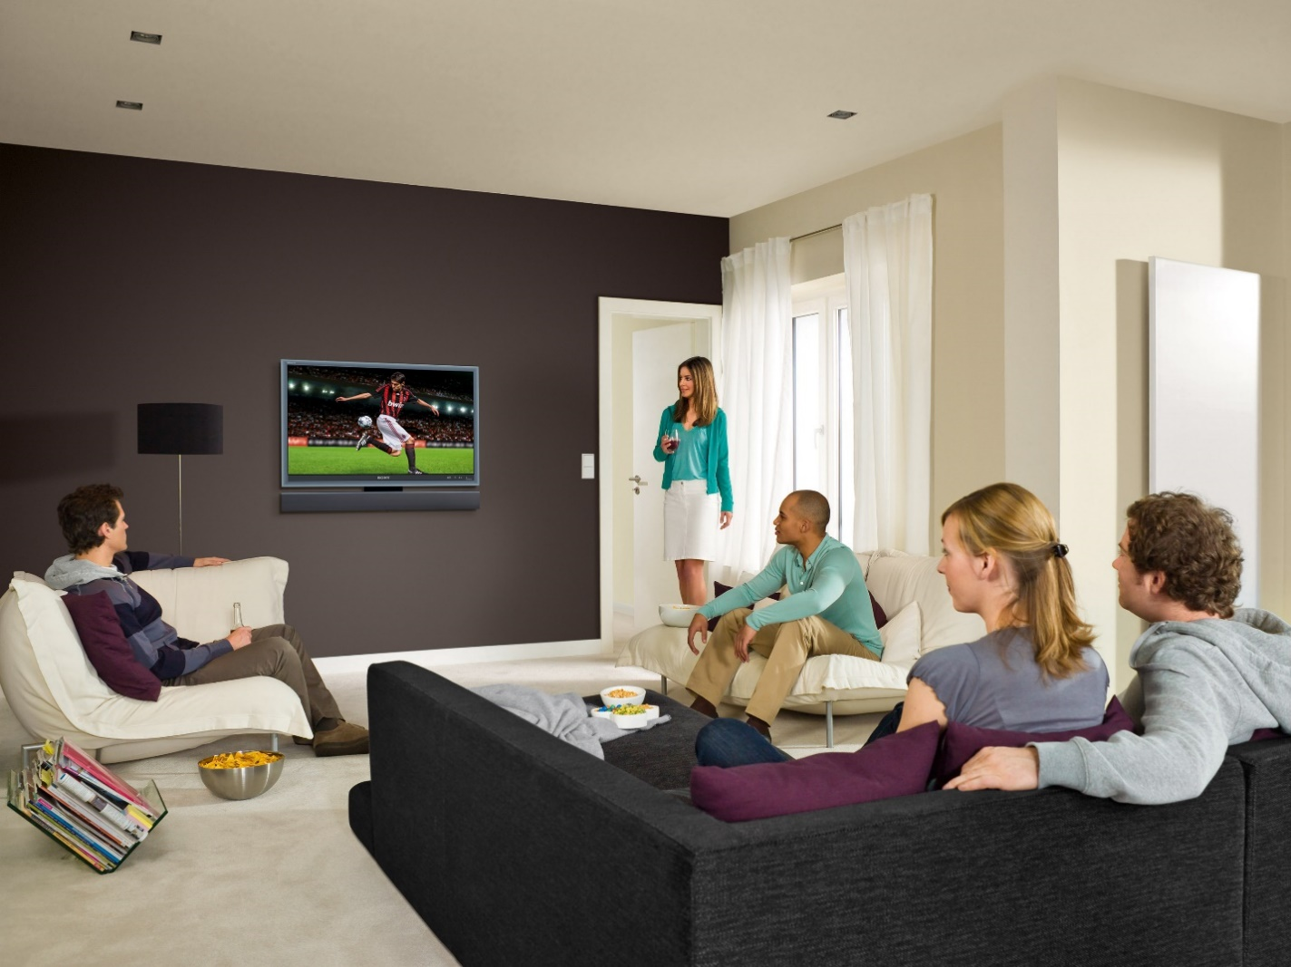

In this picture I can see 5 people. There is a black sofa in the center of the room. There's a coffee table in front of him, and there's a plate of chips on it. There is a white armchair in the left corner of the room, next to it is a magazine stand and a bowl of popcorn. There's a TV in the center of the wall, and football is playing on it. There is a black lamp to the left of the TV. There is an exit to the balcony to the right of the TV. There is another white sofa under the window to the balcony.

Mark and Anna are sitting on a black sofa. They're sitting on the sofa and watching TV. Mark is wearing a grey sweatshirt and jeans. Anna is wearing a black blouse and blue pants.

Max is sitting on a white sofa. He is wearing a green turtleneck and beige trousers. He also watches football on TV.

Monica is standing in the doorway, holding a cup of tea in her hand and also watching TV. Monica is wearing a green blouse and a white skirt.

Jack is sitting on a white armchair. He's wearing a striped sweatshirt and brown pants. He drinks beer and watches football.